Microsoft Word Tips and Tricks

TRU provides all students with access to Microsoft Office 365, a subscription-based software package that includes Microsoft Word. For more information, go to: **https://www.tru.ca/its/students/software/office-365.html**.

* Set the default font for the entire document using the Fonts button on the Design tab.   
  Click on “Customize Fonts” and select the same font for the Heading and Body fonts.
* Set the default line spacing for the document using the button on the Design tab, then click on “Custom Paragraph Spacing” to remove extra spaces after paragraphs.
* Set the font size using the Font dialog box . Select a size, then click on .
* Graphical user interface, application, table, Teams

  Description automatically generatedUse the Page Number function on the Insert tab. If you are using MLA style, add   
  your last name to the left of the page number.
* Diagram

  Description automatically generated with low confidenceUse the Special Indentation setting on the Paragraph dialog box  to create hanging indents.
* Use **Shift + Enter** to insert a line break without a paragraph break. This is particularly useful for preserving paragraph-level formatting such as hanging indents.
* Use **Ctrl + Enter** to insert a page break. This is useful when you want an element such as References or Works Cited to appear consistently at the top of a new page.
* Use the Share function on the File tab to email the document. (This only works if you are signed into Microsoft Outlook.)
* Save a document to your OneDrive personal storage to access it across all your devices. (This only works if you’re using Word 365.)
* Use the Undo and Redo functions to fix mistakes.
* Use the Change Case function on the Font group to adjust the case of text.
* Graphical user interface, application, Word

  Description automatically generatedWhen pasting a reference into a document from another source, use the “Merge Formatting” option to put the text into the default font while preserving the italicization.
* Alphabetize references using the Sort function in the Paragraph group.
* Icon

  Description automatically generatedShape

  Description automatically generated with low confidenceSave time typing with the Dictate function on the Home tab.
* Proofread your work using the Read Aloud function on the Review tab.
* Use keyboard shortcuts (see over) to save time and avoid repetitive stress injury.

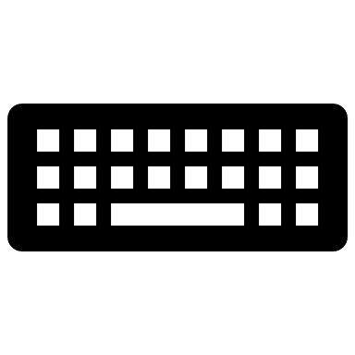Microsoft Word Keyboard Shortcuts

# General Commands

**Enter** ­­­­= Line break with paragraph break

**Shift** + **Enter** = Line break without paragraph break

**Ctrl** + **Enter** = Page break

**Shift** + **àßáâ** = Select text

# Navigation

**Home** = Beginning of line  
**Ctrl** + **Home** = Beginning of document

**End** = End of line

**Ctrl** + **End** = End of a document

**PgUp**, **PgDn** = Up or down one screen

**Ctrl** + **PgUp**, **PgDn** = Up or down one page

**Ctrl** + **àß** = Right or left one word

**Ctrl** + **áâ** = Up or down one paragraph

**Ctrl** + **A** = Select **A**ll

**Ctrl** + **X** = Cut

**Ctrl** + **C** = **C**opy

**Ctrl** + **V** = Paste

**Ctrl** + **S** = **S**ave

**Ctrl** + **P** = **P**rint

**Ctrl** + **O** = **O**pen

**Ctrl** + **W** = Close

**Ctrl** + **Y** = Redo

**Ctrl** + **Z** = Undo

**Ctrl** + **F** = **F**ind

**Ctrl** + **H** = Find and Replace

# Character Level Commands

**Ctrl** + **B** = **B**old

**Ctrl** + **I** = **I**talicize

**Ctrl** + U = **U**nderline

**Ctrl** + **]** = Make text bigger   
**Ctrl** + **[** = Make text smaller

# Paragraph Level Commands

**Ctrl** + **E** = Center   
**Ctrl** + **1** = Single Space

**Ctrl** + **2** = Double space

**Tab =** Initial indent

**Ctrl** + **T** = Hanging Indent

# Styles

**Ctrl** + **Alt** + **1** = Heading Level 1

**Ctrl** + **Alt** + 2 = Heading Level 2, etc.